Phanteks Eclipse PF500 Air Mid-Tower Computer Case / Gaming Cabinet - Black | Support - E-ATX, ATX, Micro-ATX, Mini-ITX | Pre-Installed 2 x 140 mm Fans - PH-EC500ATG_BK01

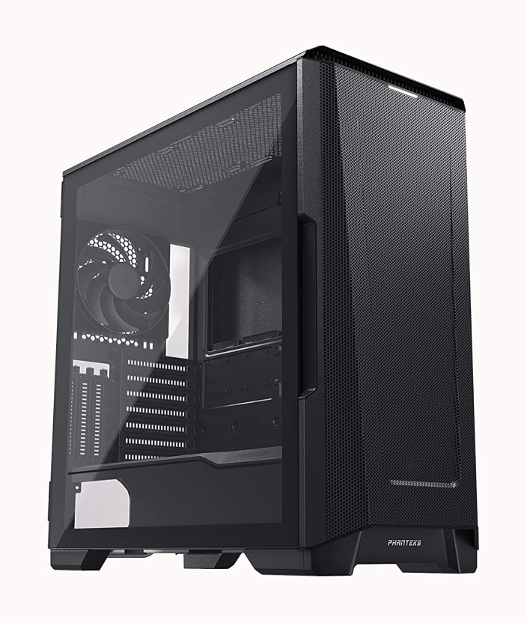

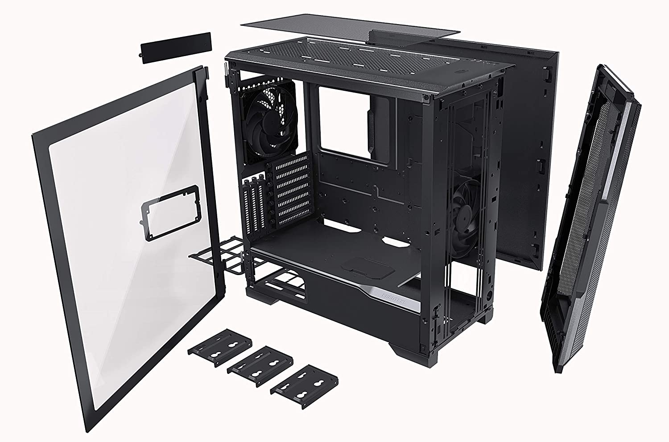

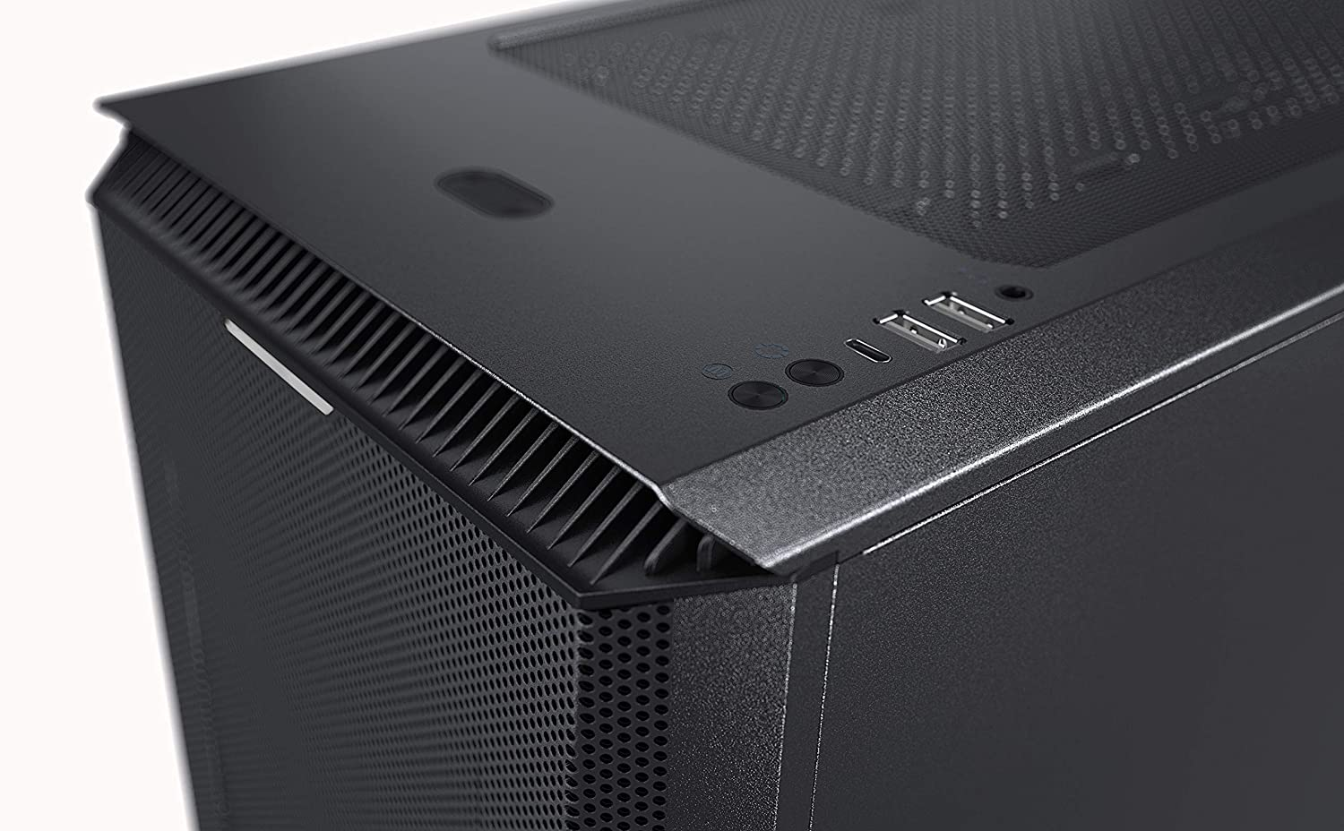

|  |  |
| --- | --- |
| M.R.P.: | ₹13,999 |
| Deal Price: | ₹11,198 |
| You Save: | ₹2,801 (20%) |
|  | Inclusive of all taxes |

### Product details

|  |  |
| --- | --- |
| Brand | Phanteks |
| Colour | Black |
| Material | Alloy Steel |
| Cooling Method | Air |
| Item Weight | 8000 Grams |
| Item Dimensions LxWxH | 50.5 x 24 x 51 Centimeters |

* Stain Black, Mid-Tower , 240 mm x 510 mm x 505 mm (W x H x D), Steel Chassis
* PCI Slots - 7+3 ; Internal Bay - 10 x 3.5"/ 3 x 2.5"
* USB-C GEN 2, 2x USB 3.0, Microphone/Headphone, Power Button, Reset Button
* Pre-Installed 2 x 140 mm Fans
* CPU Cooler - 190 mm